Nexora administration and access
Document 20 of the Nexora learning guides
Source snapshot 14 October 2026 at 06:41 UTC
Understand staff users, security groups, permission assignment and tenant protection.

Recognise the screen and its scope
Open /settings/users, /settings/security-groups. CRM routes use port 3017; member routes use 3018; public website routes can use 3019. Brackets name a route parameter, not text to paste into a browser. Choose a real record or site id from the application.
This guide covers Staff user lists and forms; Security groups; Permission matrix; Protected system administrator; User activation and passwords; Concurrency stamps and current access.
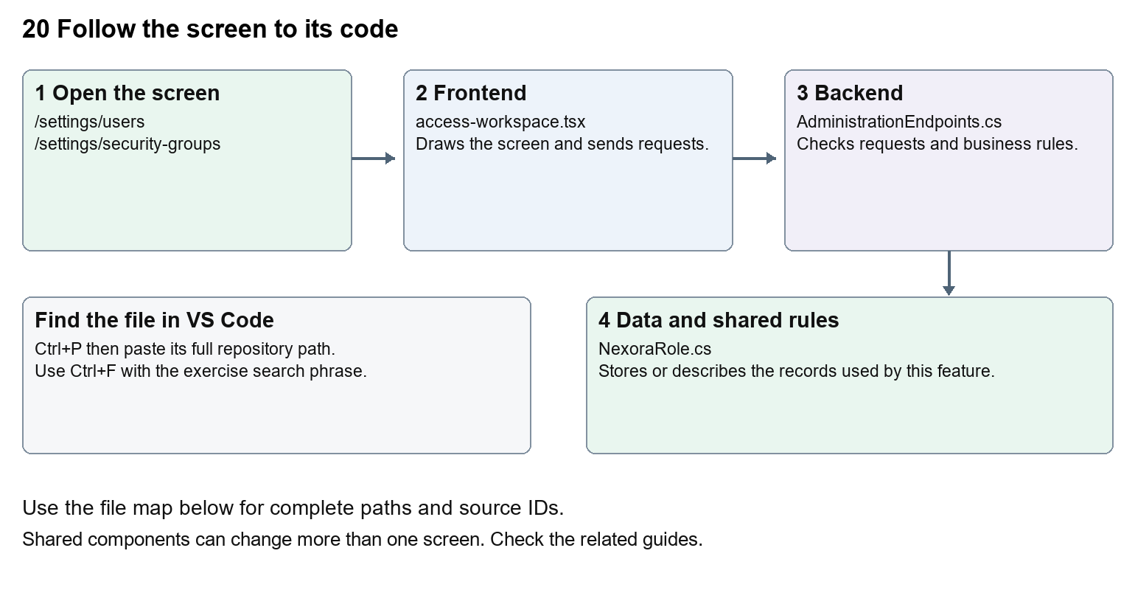
The diagram shows the file roles. The full paths below are what you paste into Ctrl+P.

Find the files in VS Code
Role | File and source ID | What it does
Screen | S0064 access-workspace.tsx | Main UI or route for this topic
Server | S0371 AdministrationEndpoints.cs | Endpoints or server rules
Data | S0374 NexoraRole.cs | Data shape or persistence structure

Screen S0064
apps/web/src/features/administration/access-workspace.tsx
Server S0371
backend/src/Modules/Nexora.Modules.Identity/AdministrationEndpoints.cs
Data S0374
backend/src/Modules/Nexora.Modules.Identity/Domain/NexoraRole.cs
The complete HTML manual opens these source IDs inside its Source library. The Word manual shows short labelled extracts so you can learn the flow before reading large files. Each individual Markdown guide includes its complete primary files after the walkthrough.

Follow the request and the records
1. The settings route requires the staff session and identity.read.
2. AccessWorkspace loads users, groups and available permissions.
3. An authorised form sends user or group changes with its concurrency stamp.
4. AdministrationEndpoints validate protected accounts and group permissions.
5. Fresh claims and active-tenant authorisation determine later request access.

Read the code with an explanation
Security groups are backed by Identity roles with permissions. A user can belong to several groups. Human-friendly permission labels do not change the underlying strings such as crm.read. Server rules protect system accounts and tenant scope. A concurrency stamp is a version marker which prevents overwriting a newer change.
Source reference S0064 apps/web/src/features/administration/access-workspace.tsx
Selected opening lines with their original numbers. The complete file is in the HTML source library.
0001 "use client";
0002 import { WorkspaceHeading } from "@/components/ui/workspace-heading";
0003 import { RecordListing } from "../shared/record-listing";
0004 import listingStyles from "../crm/record-listing.module.css";
0005 import { ArrowLeft, Plus } from "lucide-react";
0007 import { useEffect, useState } from "react";

The import lines lead to shared components and helpers. Start at the exported component or route function; follow the request helper to the server rather than assuming the whole feature lives in this file.
Source reference S0371 backend/src/Modules/Nexora.Modules.Identity/AdministrationEndpoints.cs
Extract from source line 23. A fragment from a long line is shown without the rest of that line.
0023 var api = routes.MapGroup("/api/v1/admin").WithTags("Administration").RequireAuthorization(NexoraPermissions.IdentityRead);

On the server, look for MapGet to load records, MapPost to create or perform an action, MapPut or MapPatch to change data, and RequireAuthorization for permissions. Some shared methods register endpoints indirectly. Find SaveChangesAsync to see the database write. A request method alone does not tell you every side effect.
Source reference S0374 backend/src/Modules/Nexora.Modules.Identity/Domain/NexoraRole.cs
Selected opening lines with their original numbers. The complete file is in the HTML source library.
0001 using Microsoft.AspNetCore.Identity;
0003 namespace Nexora.Modules.Identity.Domain;
0005 public sealed class NexoraRole : IdentityRole<Guid>
0006 {
0007 public Guid TenantId { get; set; }
0008 public string? Description { get; set; }

Follow model fields to their request names and database mapping. An id points to a particular record. A tenant id limits the organisation. A version or concurrency stamp protects newer edits. Some model files describe contracts rather than tables; check the owning DbContext before assuming storage.

Make or trace your first change
1. Press Ctrl+P and open apps/web/src/features/administration/access-workspace.tsx.
2. Press Ctrl+F and search for Files and evidence. In this snapshot it appears at line 20.
3. Replace this human-readable permission label in permissionNames only. Inspect the permission matrix. Leave the files key and crm.files permission string unchanged.
4. Replace only Files and evidence with Documents and evidence in that intended location. Keep quotes, tags, JSON keys and routes intact.
5. Save with Ctrl+S. Inspect Problems and the local screen. Review the diff and restore the original text when you finish practising.
Extract from source line 20. A fragment from a long line is shown without the rest of that line.
0020 ", configure: "Configure", files: "Files and evidence", decide: "Application decisions", results:

These exercises have not been applied to the application. Their search phrases are verified against the captured source. Line numbers can move; the phrase and file path are your main navigation aids.

Check a change and diagnose problems
Confirm the original screen still loads, the changed words appear in the intended place, and another screen using the same component still behaves correctly. If an action fails, inspect the browser Network response, the relevant helper and server validation message. Use the common error table at the beginning of the manual. Reload on a version conflict instead of removing the version check.
A syntax error after a text edit usually means a quote, brace or closing tag changed. Compare your diff with the original. An unchanged browser result can mean the wrong port, a saved published configuration overriding a default, or a running API that has not reloaded.

Understand the current limits
Identity management changes can lock people out or grant access. Start with label changes, and keep protected-account safeguards. Production identity and verification remain separate unfinished integration work.

Continue learning
Related guides 01 Nexora login page, 03 Nexora workspace navigation and theme, 24 Nexora member portal login and onboarding, 30 Nexora backend database and maintenance.

